Trade of Metal Fabrication
Module 1: | Basic Fabrication
Unit 12: | Abrasive Grinding and Cutting
 | Phase 2

Table of Contents
List of Figures 4
List of Tables 5
Document Release History 6
Module 1 – Basic Fabrication 7
Unit 12 – Abrasive Grinding and Cutting 7
Learning Outcome: 7
Key Learning Points: 7
Training Resources: 7
Key Learning Points Code: 7
Angle Grinder 8
Changing Discs 10
Grinding 11
Cutting Action 11
Sharpening Cutting and Small Tools 11
Precautions when Grinding 12
The Wheel 12
Wheel Balance 12
The Work Rest 12
Wheel Speed 12
British Standard Marking System for Abrasive Wheels 13
Abrasive 14
Grain 14
Grade 14
Conversion Tables 16
Self Assessment 19
Questions on Background Notes – Module 1.Unit 12 19
Index 20

List of Figures
Figure 1 - Angle Grinder 1 8
Figure 2 - Angle Grinder 2 9
Figure 3 - Angle Grinder 3 9
Figure 4 – Angle Grinder Accessories 9

List of Tables
Table 1 - Technical Data Ag 125-S Abrasive Grinder 8

Document Release History
Date | Version | Comments
24/08/06 | First draft
13/12/13 | SOLAS transfer

Module 1 – Basic Fabrication

Unit 12 – Abrasive Grinding and Cutting
Duration – 2 Hours

Learning Outcome:
By the end of this unit each apprentice will be able to:
- Identify various grades of grinding disc by specification
- State the types of portable grinding machines
- Describe an abrasive wheel cutting machine
- Identify types of cutting and grinding discs used with angle grinder
- Identify safety procedures

Key Learning Points:
Rk | Types and grades of grinding discs.
Rk | Specifications.
Rk Sk | Changing discs.
Rk H | Ratio of speeds between machine and discs.
Rk H | Portable grinders.  (See “Portable Grinding Machines” section in Module 1 Unit 10).
Rk H | Cutting and grinding discs.
Rk H | Abrasive wheel cutting machines.  (See “Abrasive Wheel Cutting-Off Machines” section in Module 1 Unit 10).
Rk H | Safety procedures – safety awareness.  (See “Basic Safety Rules” section in Module 1 Unit 10).
P | Communication, safe work practice and attitude.

Training Resources:
Workshop – portable grinders. Hand tools, drills. Types of specifications. Sample wheel. Instructor lecture and demonstrations. Texts, notes and handouts.

Key Learning Points Code:
M = Maths D= Drawing RK = Related Knowledge Sc = Science
P = Personal Skills Sk = Skill H = Hazards

Angle Grinder
Uses:
- Grinding and cutting steel and metal

Power Input | 1020 V
Power output | 600 W
No-load speed | 11.000 r.p.m.
Cutting disc diameter | Max. 125 mm
Drive spindle thread | M14
Cutting depth | Max. 35 mm
Weight | Approx. 1.8 kg
Table 1 - Technical Data Ag 125-S Abrasive Grinder

Features:
- Dust protection for longer carbon brushes life
- A slimmer design that lies well in the hand
- Permanent on/off switch
- Low vibration side handle (optional)
- Side handle can be mounted on the left or right
- Additional cooling slots for perfect cooling

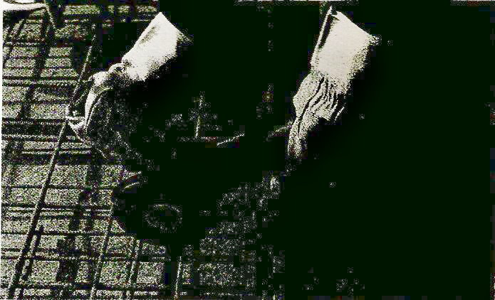
Figure 1 - Angle Grinder 1

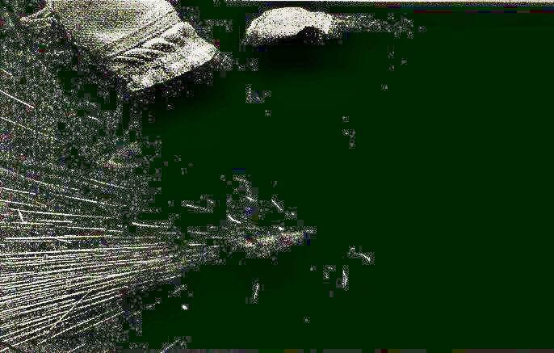
Figure 2 - Angle Grinder 2

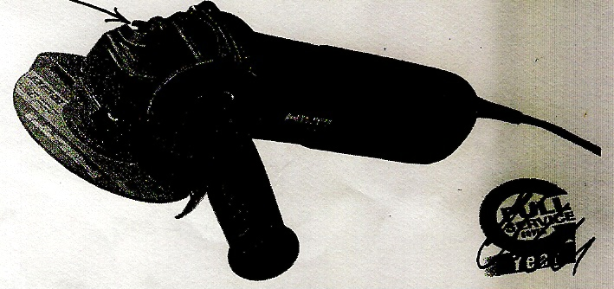
Figure 3 - Angle Grinder 3

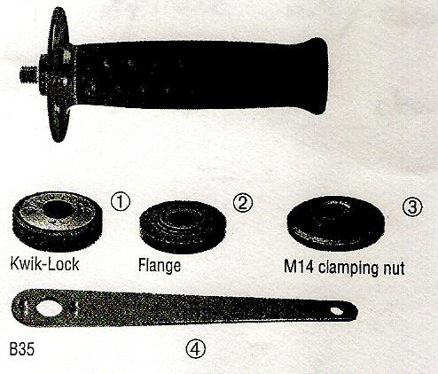
Figure 4 – Angle Grinder Accessories
- Kwik-lock nut
- Flange
- M14 clamping nut
- B35 pin wrench
Tool for changing discs.

Changing Discs
To mount a grinding/cutting disc on an angle–grinder:
- Select a disc – cutting, grinding, size etc.
- Make sure that they are no defects in the disc (visually examine for cracks).
- All mating parts should be clean and free from grease
- Disc/flange faces
- Spindle threads/flange threads (if threaded type)
- Assembly
(a) Flanges located in correct position
(b) Spindle nut/clamping nut seated properly over disc securing it in position
(c) Pressing in bottom to hold/lock disc whilst tightening spindle nut/clamping nut
(d) Use pin wrench/tool for changing discs

Grinding

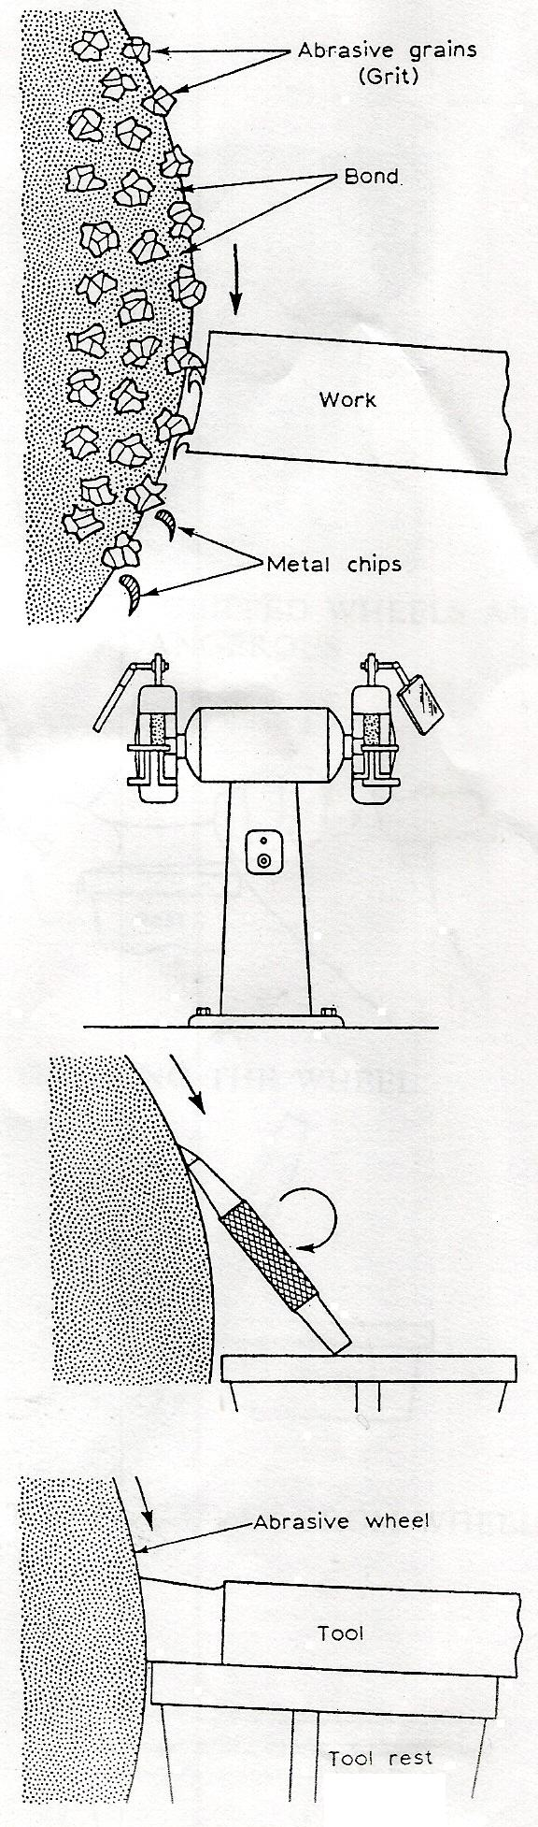
Cutting Action
The grinding wheel is made up of small grains of abrasive material called grit. The grit is embedded in a softer substance called the bond. The grit size and the bond material will vary according to the type of work on which the wheel is to be used.
If we examine an abrasive wheel closely the grit can be seen held together by the bond.
As the work is applied to the wheel the grit cuts the metal in a manner similar to a cutting tool. As the grit becomes blunt, voids which are present in the bond release the grit, which exposes new grit to continue the cutting action.

Sharpening Cutting and Small Tools
Hand tools such as cold chisels, centre punches and scribers are easily and quickly sharpened on the off hand grinding machine (shown opposite). Drills can, and are, frequently sharpened on the off hand grinder.
Large drills, however, cannot be sharpened accurately and must be ground on a special machine or by using a fixture attached to the off hand grinder.
Single point tools as used on the lathe or sharper will frequently require sharpening. This can be achieved by setting the tool rest to the required angle and applying the tool to the wheel of the off hand grinder as shown here.

Precautions when Grinding

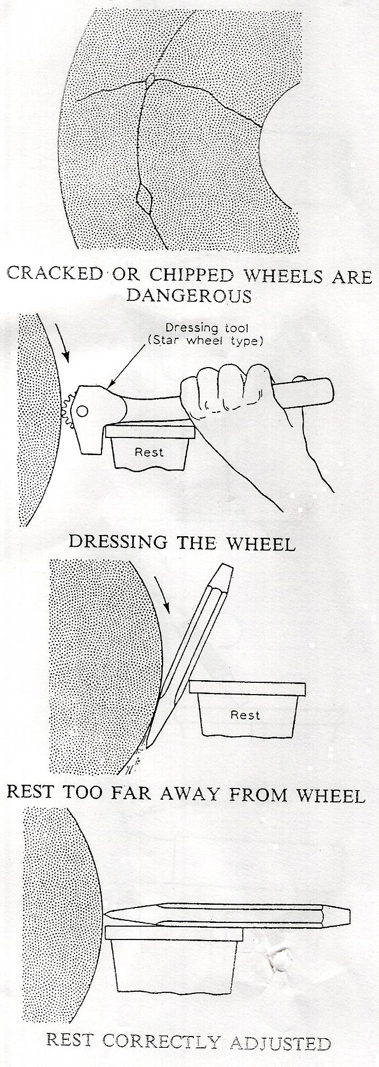
The Wheel
Due to the nature of its construction the wheel can, if not carefully treated, crack or even shatter during use. To reduce the danger of flying particles causing injury, the wheel must be guarded with only the working area exposed. Examine the wheel frequently for cracks or other defects.
When grinding move the work from side to side to avoid cutting grooves in the wheel. Use the front of the wheel as much as possible. If the side of the wheel is used avoid using too much force.

Wheel Balance
During use it is quite common for the wheel to wear unevenly so that it runs out of true. Excessive vibration when running usually indicates that the wheel is out of balance.
The wheel can be trued up by using an abrasive stick or a star wheel dresser as shown.
Dressing the wheel also opens up the grit if the wheel has become loaded (blocked with dirt, grease or other matter).

The Work Rest
When using the off hand grinder the work rest must be as close to the wheel as possible. Failure to observe this rule may result in the work becoming jammed between the wheel and rest.

Wheel Speed
Never exceed the manufacturer’s recommended wheel speed. This speed is clearly indicated on the label on the side of the wheel. Always mount the wheel correctly.

British Standard Marking System for Abrasive Wheels
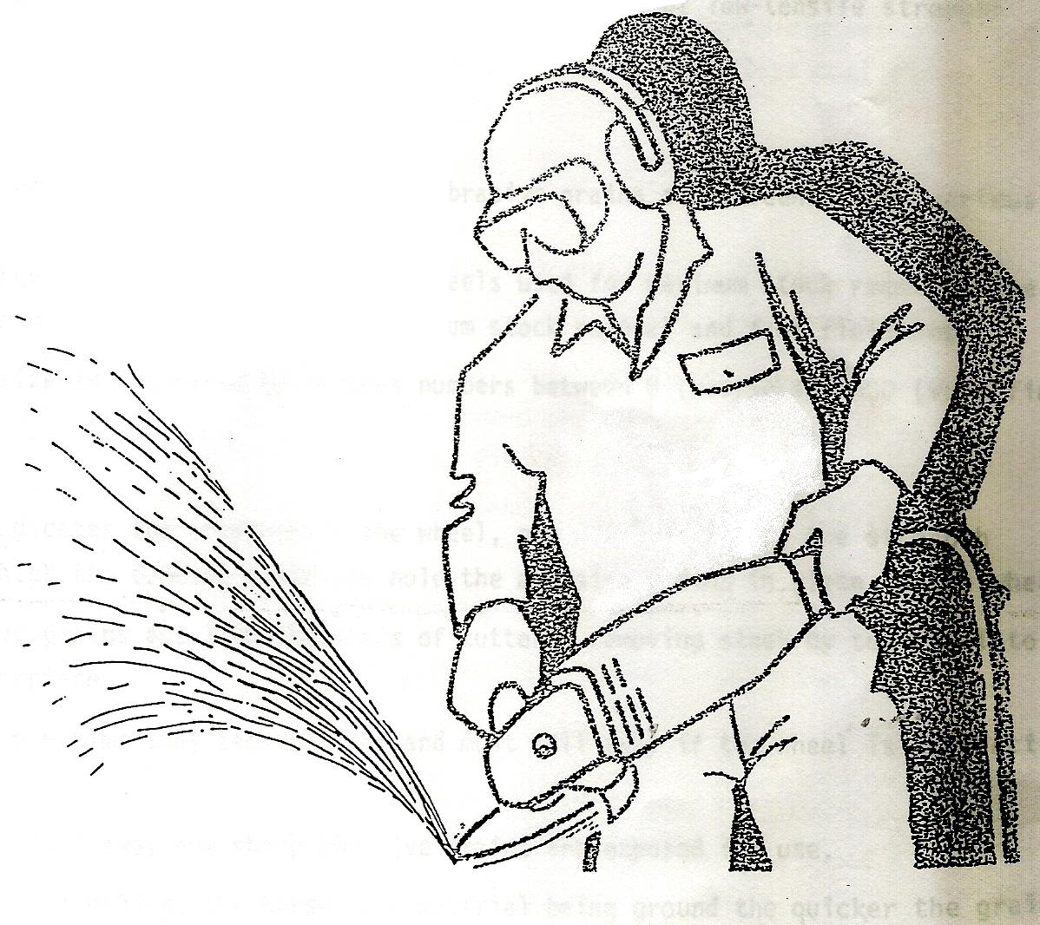

The British Standard Marking System denotes the composition an9 qualities of abrasive wheels.
All wheels are marked to show 5 qualities:
ABRASIVE
GRAIN
GRADE
STRUCTURE
BOND

A thorough understanding of this marking system will help one to always select the correct abrasive wheel for the particular job in hand.

Abrasive
The symbols ‘A’ or ‘C’ denote the abrasive used;
‘A’ - Aluminium Oxide - is ideal for grinding high-tensile material like steel.
‘C’ - Silicon Carbide - is used to grind materials of low-tensile strength like masonry or cast iron.

Grain
Aluminium Oxide and Silicon Carbide abrasive grains are screened into various sizes.
The larger grains are contained in wheels used for maximum stock removal, the smaller ones in wheels used for minimum stock removal and fine finishing.
Grain size is indicated by various numbers between 8 (coarse) and 600 (very fine).

Grade
This indicates the strength of the wheel, or, more precisely, the strength with which the bonding materials hold the abrasive grains in the wheel.
Abrasive grains act like thousands of cutters removing stock by tearing into the workpiece.
After some time they become blunt and must fall away if the wheel is to function correctly.
As they fall away new sharp abrasive grains are exposed for use.
Generally speaking, the harder the material being ground the quicker the grains lose their edge.
So, for grinding hard materials a soft grade wheel is used and for grinding soft materials a hard grade wheel is used.
Using too hard a wheel on a hard workpiece generates too much heat. This glazes the wheel and ruins the workpiece.
Using too soft a wheel on a soft workpiece results in excessive wheel wear and wastage.
Grade selection is made from an alphabetical list from A to Z.
‘E’ e.g. denotes a soft grade wheel suitable for grinding very hard materials like tungsten carbide and stainless steel.
‘U’ e.g. denotes a hard grade wheel suitable for grinding soft materials like aluminium.

A
C
For High-Tensile Materials e.g. Steel
For Low-Tensile Materials e.g. Cast Iron
Large Grain
Small Grain
For Maximum Stock Removal & Coarse Finish
For Minimum Stock Removal & Fine Finish
ABRASIVE
GRAIN
Soft Grade
Hard Grade
For Hard Materials e.g. Stainless Steel
For Soft Materials e.g. Aluminium
GRADE
Dense
Open
For Hard & Brittle Materials e.g. Hardened Steel
For Soft Materials e.g. Soft Steel
STRUCTURE
Vitrified
Resinoid
Used only on Fixed Machines
Used only on Portable Machines
BOND

Conversion Tables
Sometimes instead of in r.p.m., wheel speeds are shown in surface feet per minute (S.F.P.M.) – that is, the number of feet the circumference of the wheel would travel in one minute.

Surface Feet per Minute to Revolutions per Minute
For surface speeds greater than 10,000 S.F.P.M. take half the diameter and double the r.p.m. from the chart below.
Note: Vitrified bond must never exceed 6,500 S.F.P.M. Organic bond (resinoid, rubber or shellac) may exceed 6,500 S.F.P.M.

Grinding Wheel Speeds
High Speed Table
Diameter of Wheels |  | 7,000 S.F.P.M. | 8,000 S.F.P.M. | 9,000 S.F.P.M. | 10,000 S.F.P.M.
Ins. | m/m | r.p.m. | r.p.m. | r.p.m. | r.p.m.
1 | 25.4 | 20,738 | 30,558 | 34,377 | 38,197
2 | 50.8 | 13,369 | 13,279 | 17,159 | 19,098
3 | 70.2 | 8,913 | 10,188 | 11,459 | 12,732
4 | 101.6 | 6,684 | 7,639 | 8,304 | 9,549
5 | 127 | 5,347 | 6,111 | 6,573 | 7,639
6 | 152 | 4,466 | 5,093 | 5,729 | 6,366
7 | 178 | 3,820 | 4,363 | 4,911 | 5,457
8 | 203 | 3,342 | 3,820 | 4,297 | 4,775
10 | 254 | 2,674 | 3,056 | 3,439 | 3,820
12 | 305 | 2,223 | 2,546 | 2,563 | 3,183
14 | 356 | 1,910 | 2,183 | 2,455 | 2,728
16 | 406 | 1,671 | 1,910 | 2,148 | 2,357
18 | 457 | 1,485 | 1,698 | 1,910 | 2,122
20 | 503 | 1,337 | 1,528 | 1,719 | 1,810
22 | 559 | 1,215 | 1,359 | 1,563 | 1,756
24 | 609 | 1,114 | 1,273 | 1,432 | 1,591
26 | 660 | 1,028 | 1,175 | 1,322 | 1,469
28 | 711 | 966 | 1,091 | 1,226 | 1,364
30 | 762 | 891 | 1,018 | 1,140 | 1,273
32 | 813 | 835 | 955 | 1,074 | 1,194
34 | 863 | 786 | 899 | 1,101 | 1,123
36 | 914 | 743 | 840 | 833 | 1,061

Grinding Wheel Speeds
Low Speed Table
Diameter of Wheels |  | 4,000 S.F.P.M. | 5,000 S.F.P.M. | 6,000 S.F.P.M. | 6,500 S.F.P.M.
Ins. | m/m | r.p.m. | r.p.m. | r.p.m. | r.p.m.
1 | 25.4 | 15,279 | 10,098 | 22,918 | 24,828
2 | 50.8 | 7,639 | 9,549 | 11,459 | 12,414
3 | 70.2 | 5,093 | 6,368 | 7,639 | 8,276
4 | 101.6 | 3,820 | 4,775 | 5,729 | 6,207
5 | 127 | 3,066 | 3,820 | 4,584 | 4,906
6 | 152 | 2,548 | 3,183 | 3,820 | 4,138
7 | 178 | 2,183 | 2,723 | 3,274 | 3,547
8 | 203 | 1,910 | 2,387 | 2,805 | 3,103
10 | 254 | 1,528 | 1,910 | 2,292 | 2,483
12 | 305 | 1,273 | 1,591 | 1,910 | 2,069
14 | 356 | 1,091 | 1,304 | 1,637 | 1,773
16 | 406 | 956 | 1,194 | 1,432 | 1,532
18 | 457 | 849 | 1,001 | 1,273 | 1,379
20 | 503 | 764 | 955 | 1,146 | 1,241
22 | 559 | 694 | 868 | 1,042 | 1,128
24 | 609 | 637 | 796 | 955 | 1,034
26 | 660 | 588 | 734 | 881 | 953
28 | 711 | 540 | 682 | 818 | 887
30 | 762 | 500 | 637 | 764 | 828
32 | 813 | 477 | 597 | 716 | 776
34 | 863 | 449 | 562 | 674 | 730
36 | 914 | 424 | 530 | 637 | 690

Self Assessment

Questions on Background Notes – Module 1.Unit 12

No Suggested Questions and Answers.

Index

A
Angle Grinder, 8
B
British Standard Marking System for Abrasive Wheels, 13
Abrasive, 14
Grade, 14
Grain, 14
C
Changing Discs, 10
Conversion Tables, 16
G
Grinding, 11
Cutting Action, 11
Sharpening Cutting and Small Tools, 11
P
Precautions when Grinding, 12
The Wheel, 12
The Work Rest, 12
Wheel Balance, 12
Wheel Speed, 12

